REGION 3 MONTHLY LUNCHEON
www.alabamaparalegals.net
Don’t forget to check out our Facebook page for upcoming events and news: https://www.facebook.com/groups/47141898343/

SPEAKER:
Paul Giardina
Executive Director
Ronald McDonald House Mobile

TOPIC:

Ronald McDonald House
Charities of Mobile
“The House That Love Built”

Region 3 Donation Drive

To Register:

Please register in advance for this meeting at:
Alabama Association of Paralegals, Inc. - Home Page (alabamaparalegals.net)
or
Kim.Tillman@Mobilecountylc.com
(251) 574-1952
After registering, you will receive a confirmation email.

This seminar meets the requirements of the NALA Certifying Board for continuing legal education credit required to maintain the CP (Certified Paralegal) credential. It has been approved for 1-hour of CLE credit.

LOCATION:
The Original Oyster House
3733 Battleship Pkwy.
Spanish Fort, AL

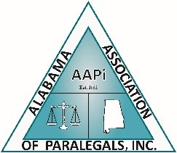
Wednesday,
Sept. 21, 2022
12:00 p.m. – 1:00 p.m.

Cost: $18.00

Bring a friend and a donation for the Ronald McDonald House

